Healthwatch York
Annual Stakeholder Report
June 2026
Executive Summary
This report summarises the findings of Healthwatch York’s annual stakeholder survey, conducted to gauge views on the value of an independent voice function within the local health and care system, and to assess satisfaction with Healthwatch York's performance over the past year.
The survey gathered responses from a wide range of partners including councillors, local authority and Integrated Care Board representatives, commissioners, voluntary and community sector (VCSE) organisations, volunteers and individuals with lived experience. The findings are overwhelmingly positive, demonstrating strong support for Healthwatch York’s continued operation and deep concern at the prospect of its abolition.
Key statistics
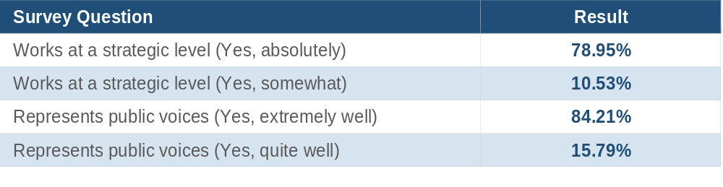
Partnerships
Respondents consistently described their experience of working with Healthwatch York in strongly positive terms. Common themes included professionalism, approachability, and the genuine value placed on lived experience.
"Personable and professional. Always happy to help. Highly skilled team. Pleasure to work with." Anonymous
"Their approach was thoughtful, inclusive and well evidenced, with real care taken to centre lived experience while grounding findings in practical insight that the system can act on." Tom Warren-Dolman, NHS Humber & North Yorkshire ICB.
"Working with Healthwatch York has been transformative to our work as a small VCSE organisation. They go above and beyond in their efforts to truly understand the needs of our community, using their voices and roles to advocate for us, without ever speaking for us." Anonymous

Respondents particularly valued the non-adversarial, inspiring approach taken during visits and engagement activities, with one care provider noting that staff felt validated and endorsed rather than scrutinised.
Use of reports and information
A significant proportion of respondents reported actively using Healthwatch York’s materials to inform their work. Key publications cited included:
- The Trans, Non-Binary and Intersex (TNBI) Health Report
- The Dementia Guide
- Mental health reports and guides “the work on the various aspects of mental health has helped to inform planning and practice” Cllr Carol Runciman
- Enter & View reports on care homes
- Women's long-term health conditions report
- Neurodiversity and Core Connectors reports
Reports were used for a range of purposes, from informing inspection activity and improving accessibility, to supporting advocacy with MPs and clinical educators. One respondent noted that Healthwatch York materials provided credibility and authority to feedback that might otherwise be dismissed.
"The report was very useful for providing respected and balanced information that supports requests for improvements to services, education and the need for investment in scientific research." Nicky Proctor representing the York ME community.
“This information is useful as it provides an external, independent perspective on patient experience, which complements our own internal survey data. It can help validate themes we are seeing locally and highlighting areas that may require further exploration or system-level action” Nicole Zannikos, Haxby Group York.
Strategic role and representation
Nearly 90% of respondents confirmed that Healthwatch York operates at a strategic level, either absolutely or to some extent. All respondents felt that Healthwatch York represents public voices well, with 84% rating this as excellent.
Stakeholders described Healthwatch York as a trusted link between communities and system leaders, providing independent insight that complements internal data and holds the system to account.
"Healthwatch York brings an independent, trusted voice into the local health and care system by capturing and amplifying lived experience, particularly where it may not otherwise be heard." Tom Warren-Dolman, NHS Humber & North Yorkshire ICB.
"It brings a keen edge to thinking about key matters by bringing forward the patients' and potential patients' voice. Its methodology and analysis are especially impressive." Anonymous
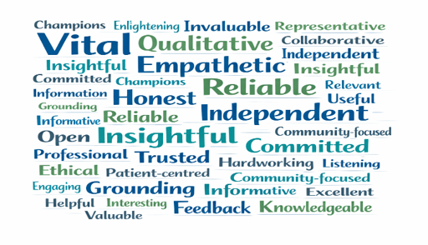
Suggested areas for future work
Underrepresented Communities
Several respondents identified groups that may benefit from more targeted engagement:
- Working-age adults balancing employment and caring responsibilities.
- Digitally excluded patients.
- People from communities with high levels of deprivation.
- Carers, veterans, and people who do not typically engage with formal feedback routes.
Priority Topics
Respondents suggested the following as areas for future focus:
- Hospital discharge and reablement services.
- Chronic kidney disease and cardiovascular health.
- Access to screening programmes for people with mobility, learning, or work barriers.
- The relationship between the NHS and the private sector.
- Digital health tools (wearables, virtual wards, NHS app improvements).
- Independence, loneliness, and social care provision.
- Health checks for the over-40 population.
- Nutrition education and provision (schools, hospitals).
Value to the local health and care system
Respondents articulated a clear and consistent picture of the unique value Healthwatch York brings, including:
- An independent, trusted mechanism for capturing public voices; especially those least likely to engage through formal channels. "Sense checking. Challenge. Insights we wouldn't have capacity to capture ourselves. Trusted representative for local community. Capture voices we wouldn't usually hear." Anonymous
- A system-wide perspective that organisations cannot replicate individually.
- Constructive challenge and accountability, delivered in a collaborative rather than adversarial way.
- Strong value for money: relatively modest budgets generating insight that prevents repeat failures. "If Healthwatch were abolished, a key loss would be its strong value for money: relatively small budgets generate system-wide insight that helps prevent repeat failures and supports more targeted service improvement. Its removal would also eliminate a trusted mechanism for capturing rich, qualitative public voices, particularly from people least likely to engage through surveys, digital feedback or formal complaints processes. Together, this intelligence ensures services are shaped by real lived experience rather than assumptions, improving effectiveness and responsiveness to what communities need and value." Anonymous
- A platform for marginalised and underrepresented communities to influence service design. "Healthwatch York brings an independent, trusted voice into the local health and care system by capturing and amplifying lived experience, particularly where it may not otherwise be heard. Their work helps bridge the gap between communities and system leaders, providing insight that is grounded in real experiences and can meaningfully inform service design, improvement and accountability. Their ability to work constructively with both residents and partners adds important balance and challenge to local decision-making." Tom Warren-Dolman:
Concerns about abolition
The prospect of Healthwatch York being abolished prompted serious concern across respondents. The losses identified were wide-ranging and consistent:
- Loss of an independent, trusted, and accessible route for raising concerns. "It simply should not be disbanded - I fear a centralised approach would lose the credibility and trust Healthwatch York have built up over the years." Miles Goring:
- Reduced insight from groups most unlikely to engage through alternative channels.
- Weakening of constructive challenge to health and care services. "The loss of 'critical voices' in recent years across many sectors as a result of funding cuts results in services being less responsive and less progressive. Healthwatch York is crucial." Anonymous
- Difficulty in restarting a similar organisation given the trust and relationships built over time.
- Increased health inequalities, particularly in underrepresented communities. "Marginalised groups and vulnerable people no longer having a voice. It's actually quite terrifying, the prospect of losing Healthwatch York and what that means for the future of healthcare services." Anonymous
- Loss of a 'safe haven' for patients who do not feel heard by providers directly.
Recommendations from stakeholders
Where respondents were asked what they would like to see if Healthwatch York continues, the majority requested more of the same. Specific suggestions included:
- Greater visibility and self-promotion of the organisation's impact and contributions. "More continual engagement with NHS staff. I was astonished at a recent primary care education workshop that most attending had not even heard of Healthwatch York or know what they do." Nicky Proctor representing the York ME community.
- Stronger feedback loops so that organisations and the public know how insights have been acted upon.
- Continued and expanded engagement with hard-to-reach groups.
- More collaboration with NHS staff and education providers, many of whom were unaware of Healthwatch York.
- A public-facing portal for people to raise views and concerns about health and social care services.
- More resources to fund and sustain the organisation's work.
Conclusion
This survey demonstrates an exceptionally strong base of support for Healthwatch York across the local health and care system. The organisation is widely recognised as professional, independent, and uniquely positioned to represent community voices; particularly those of people who face barriers to engagement with statutory bodies.
The value that Healthwatch York provides, in terms of trust, reach, insight quality, and strategic influence, would be extremely difficult to replicate through any alternative mechanism. The survey provides clear evidence that Healthwatch York is not only valued but considered essential to a fair and responsive local health and care system.
Stakeholders are unanimous in their wish for Healthwatch York to continue and grow.
Michelle Smith
June 2026

Appendix A
With thanks to all participants including:
- Cllr Carol Runciman: City of York Council
- Caroline Roberston: CPNY
- Tom Warren-Dolman: NHS Humber and North Yorkshire ICB
- Ian Cloughton
- Linda Donnellan Beevers: Amarna House, York Averyhealthcare
- Peter Smith: Healthwatch York volunteer representative
- Dr Daniel Kimberling, Nimbuscare
- Nicole Zannikos: General Manager, Haxby Group York
- Miles Goring: Lived Insights CIC
- Nimbuscare
- Carl Wain: Age UK York
- Nicky Proctor representing The York ME Community

